Intellectual Property Economy Threatened by AI
The use of intellectual property (IP) for the development of AI challenges the norms of how IP holders are typically compensated and could jeopardize the wage premium experienced in the industry. AI and large language models (LLM) are typically trained using large volumes of data scrapped from billions of web pages. These datasets used to train AI inevitably end up containing some data/text that is IP but IP holders currently are not compensated for the use of their work to train AI and LLMS. OpenAI and other companies have held that the use of copyrighted materials to train AI is fair use while IP holders are concerned about the use of their IP work without their compensation and knowledge.
Intellectual property (IP) including copyrights, patents, and trademarks incentivizes innovations by providing ownership and exclusive rights for creative works, novel ideas, new technologies, and more. Intellectual property rights contribute significantly to GDP in the United States. In 2019 IP-intensive industries accounted for $7.8 trillion in GDP (United States Patent and Trademark Office, 2019). IP industries have a wage premium because intellectual property rights holders can capitalize off their patented, trademarked, or copyrighted material through licensing, selling their rights, and owning intellectual property. In many industries intellectual property gives companies a “temporary monopoly” because other companies that replicate the IP can be sued for patent, copyright, or trademark infringement. The higher profit made in IP industries from the “temporary monopoly” results in higher wages for IP-intensive industries. In 2019 wages for IP-intensive industries were 60% higher than the average weekly wage in other industries (United States Patent and Trademark Office, 2019).
One of the main concerns for IP-intensive industries is that AI and LLMs could unintentionally produce copyrighted materials if the LLM was trained with copyrighted or trademarked material (Caldwell, 2023). The issue made headlines throughout 2023 with the news coverage of SAGFTRA strikes which concluded in early November. The SAG-AFRTRA 2023 TV/Theatrical Contracts deal addressed some concerns about the use of artificial intelligence but did not address members’ concerns about banning companies from training AI with union members’ work since the legal issue is still being resolved in courts and studied by the U.S. Copyright Office (SAG AFTRA 2023 Artificial Intelligence Resources and Summary of Tentative Agreement: TV/Theatrical Contracts).
Other workers whose wages are heavily influenced by intellectual property such as authors, manufacturers, designers, and inventors share similar concerns about the use of copyrighted, trademarked, and patented materials for training AI. The Authors Guild which represents over 14,000 members filed a class action complaint in September of 2023 against OpenAI asserting that the artificial intelligence company knowingly trains its large language models on copyrighted materials and that ChatCPT and the LLMS threaten the livelihood of authors (Authors Guild v. OpenAI Inc., 2023). Similarly, in December of 2023, the New York Times filed a complaint against Microsoft and OpenAI which included evidence that the Chat GPT-4 would replicate New York Times articles nearly verbatim (The New York Times v. Microsoft Corporation and Open AI, 2023).
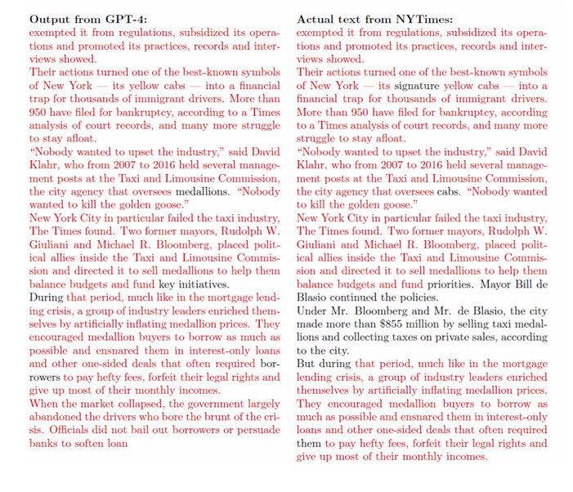
Picture: New York Times v. Microsoft and OpenAI Evidence in Complaint on GPT-4 reproducing NYTimes Article. Source: The New York Times v. Microsoft Corporation and Open AI, 2023
The ability of LLM and AI to nearly perfectly recreate IP-protected works could become a way for users to circumvent paywalls and purchasing IP works because the AI generates a nearly perfect substitute. If AI and LLMS continue to reproduce IP-protected works it could diminish the wage premiums and the “temporary monopoly” power of the IP industry.
As the courts continue to resolve these and other disputes about the regulation of AI concerning the use of IP, the courts will consider the fundamental trade-off between enabling innovation and creating regulations to protect existing structures. Whether to compensate IP holders whose work was used to support the development and training of AI and determining how to provide compensation is one of the many economic challenges posed by AI.

References:
Authors Guild v. OpenAI Inc., U.S. District Court, Southern District of New York, No. 1:23-cv-8292. https://storage.courtlistener.com/recap/gov.uscourts.nysd.606655/gov.uscourts.nysd.606655.1.0_1.pdf
Caldwell, K. (2023, October 31). AI and Intellectual Property: Who Owns It, and What Does This Mean for the Future?. Forbes. https://www.forbes.com/sites/forbesbusinesscouncil/2023/10/31/ai-and-intellectual-property-who-owns-it-and-what-does-this-mean-for-the-future/?sh=6741311a3e96
Foster, C. (2023, October 13) Intellectual Property rights and Control in the Digital Economy: Examining the Expansion of M-Pesa. The Information Society. https://www.tandfonline.com/doi/pdf/10.1080/01972243.2023.2259895?needAccess=true
SAG AFTRA (2023). Artificial Intelligence Resources. SAG AFTRA. https://www.sagaftra.org/contracts-industry-resources/contracts/2023-tvtheatrical-contracts/artificial-intelligence-resources
SAG AFTRA (2023, November 16). Summary of Tentative Agreement: TV/Theatrical Contracts 2023. SAG AFTRA. https://www.sagaftra.org/files/sa_documents/TV-Theatrical_23_Summary_Agreement_Final.pdf
The New York Times v. Microsoft Corporation and Open AI, U.S. District Court, Southern District of New York, 1:23-cv-11195. https://storage.courtlistener.com/recap/gov.uscourts.nysd.612697/gov.uscourts.nysd.612697.1.0.pdf
United States Patent and Trademark Office. (2019). Intellectual Property and the U.S. Economy: Third Edition. USPTO. uspto-ip-us-economy-third-edition.pdf

