Economics Paper Competition Division A

# Economic Link Between COVID-19 and Domestic Violence

COVID-19 wrecked havoc all over the world, leading to a massive spike in U.S. unemployment. In March 2020, 4.4% of women were unemployed. In just 1 month, female unemployment would skyrocket to 16.1% (Zarrilli & Luomaranta, 2021). Stay-at-home orders were put in place to help curb the spread of the virus in hopes of getting people back to work as soon as possible. With this, the U.S. saw an 8% increase in domestic violence following the pandemic stay-at-home orders (Mineo, 2022). This paper seeks to explain the economic link between COVID-19 and domestic violence within the United States.

COVID-19 had profound effects on Americans and the economy as a whole. Some are still reeling from it almost 3 years later. People were stuck at home and consumer spending decreased, leading to a spike in unemployment and massive drops in revenue for businesses. From 2019 to 2020 alone, median global GDP dropped 3.9% (Kates et al., 2022). With so many people losing their jobs or being sick for long periods of time, the weekly mean productivity loss was around $37.8 billion dollars. During this time, domestic violence increased from 25% to 33% globally. As stated above, the U.S. saw an 8% increase following the imposition of lockdown orders. With more people staying at home and losing their jobs, this leads one to speculate as to how domestic violence increased so dramatically.

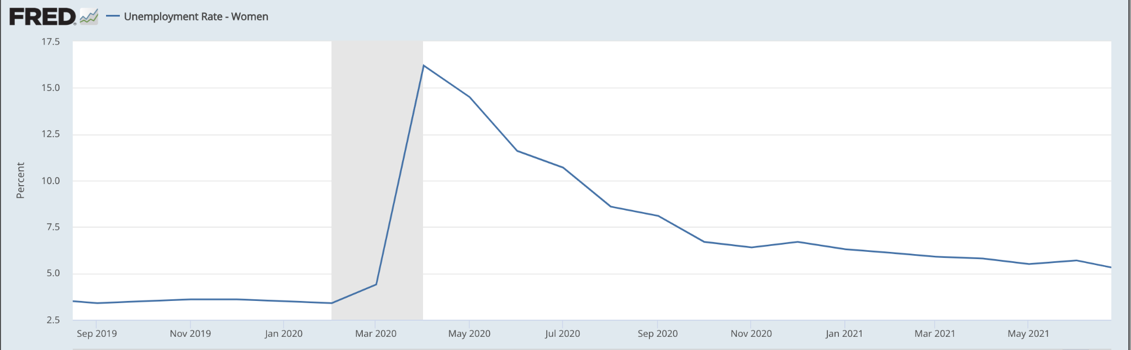

Graph 1: Female Unemployment Rate (*Unemployment rate - women,* 2023)

Even though the pandemic saw an over 25% increase in the number of women working from home, Women being home more likely isn’t to blame for the increase in domestic violence. There is no evidence to suggest that women experienced different levels of domestic violence as a result of working from home versus outside of the home (Anderberg et al., 2015). Some women were staying home not only because of the stay at home orders, but because they became unemployed. When there is a rise in female unemployment, we see a decrease in females’

relative bargaining power. The intrahousehold bargaining model suggests that domestic violence incidents increase when the relative labor market outcomes of women worsen (Anderberg et al., 2015). This is consistent with the idea that the decrease in the gender wage gap would lead to less domestic violence as it increases womens’ bargaining power (Aizer, 2010). Labor outcomes for women worsened during COVID-19 as a result of losing their jobs, which made them more susceptible to domestic violence. Married women living with their spouse were much more likely during this time to report experiencing domestic violence. This could further suggest that when there is a decreased bargaining power and some financial obligations at stake, women are more likely to experience domestic violence.

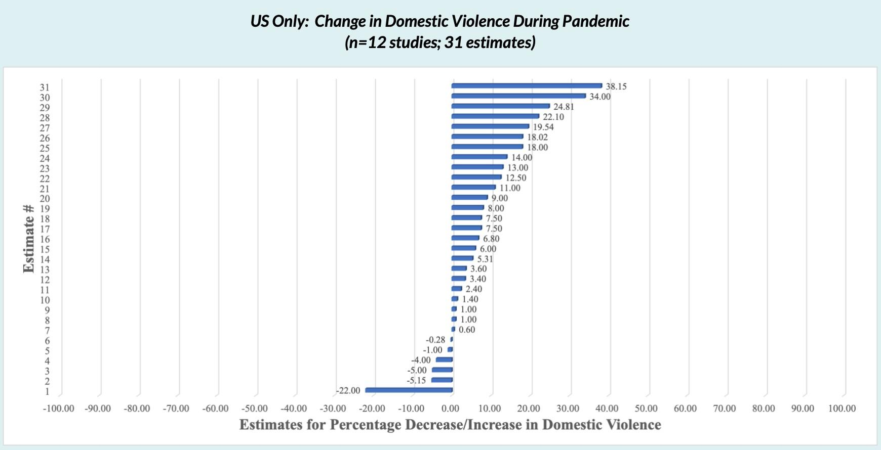

Graph 2: Domestic Violence During the Pandemic (Piquero et al., 2021)

Female unemployment might not be the only factor contributing to the rise in domestic violence. When analyzing the effects of COVID-19 on domestic violence, it is important to look back on other periods of financial turmoil as well. Looking at the great recession, declining macroeconomic conditions increased abusive behavior by increasing uncertainty and fear among a broad segment of the population (Schneider et al., 2016). Spouses may buckle under the stress of challenging economic circumstances. Let’s say the man lost his job and the woman didn’t, the abuse here could be attributed to the material hardship and not a decrease in bargaining power. In this situation, even without the loss of the female job, domestic violence against the woman is expected to increase (Schneider et al., 2016). The reality here is that regardless of who loses their job, women are still more likely to experience domestic violence.

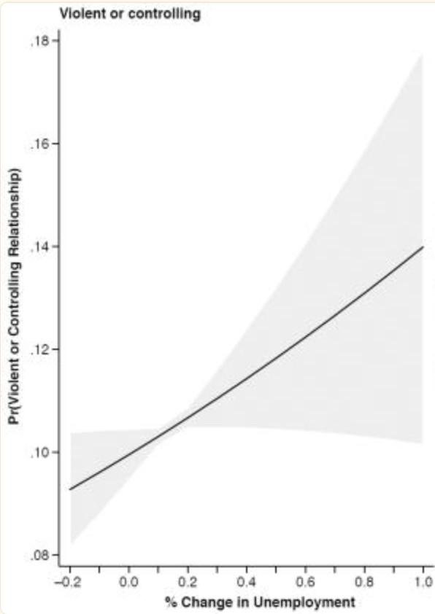

Graph 3: Change in Unemployment to Violent or Controlling Relationships During the Great Recession (Schneider et al., 2016)

Since the lockdown, there has been a decline in domestic violence within the United States (Huecker et al., 2022). We see from graph 1 that unemployment has since decreased dramatically, which could be to blame for the decline. Some of the decline could also be due to policies enacted by the government to help the unemployed, such as stimulus checks. Graph 4 shows that in April, domestic violence spiked down while the average fraction of people staying home decreased only slightly. While domestic violence increased overall due to the pandemic, this slight decrease could be due in part because of the stimulus check sent out in April. Stimulus checks, or an increase in income, leads to a significant increase in bargaining power. This shows that policies impacting income leads to decreases in violence overall.

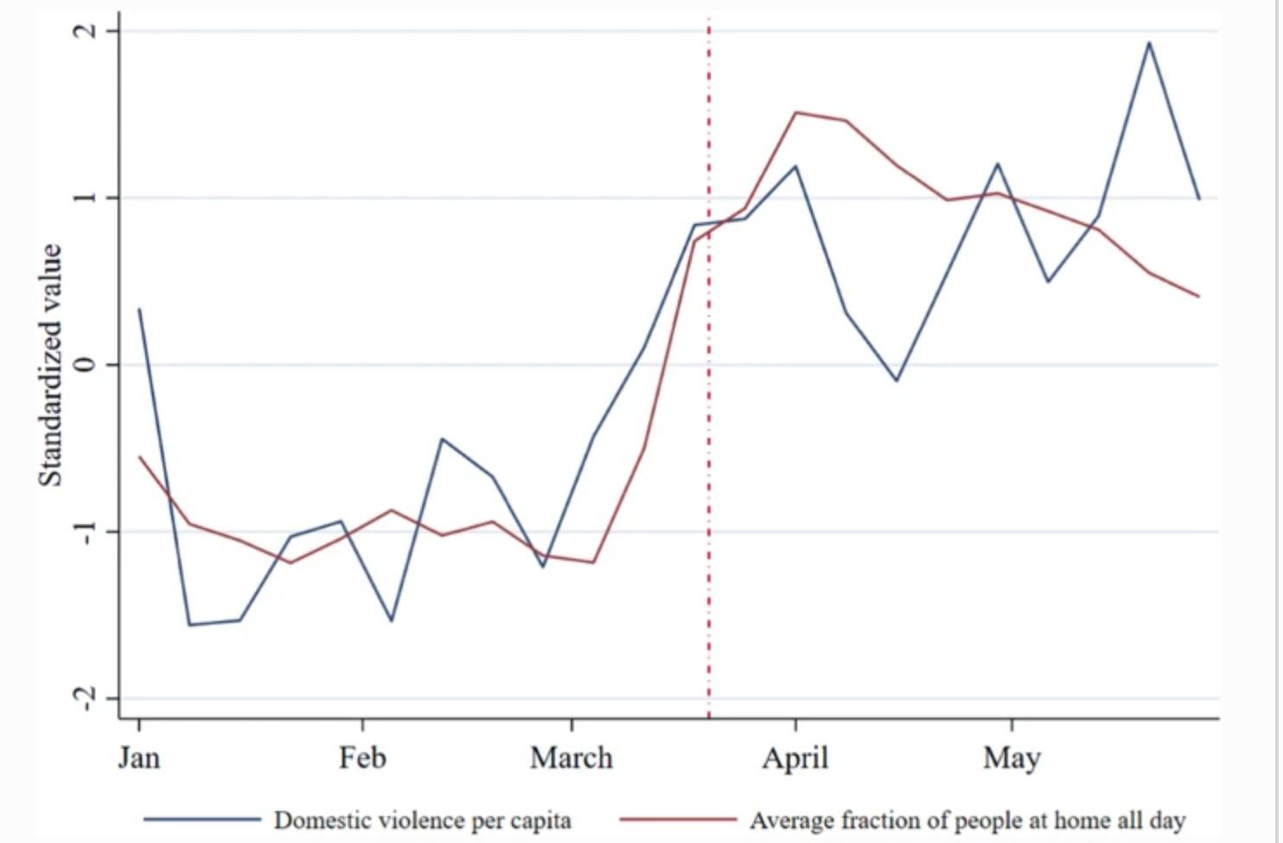

Graph 4: Domestic Violence and People at Home (Hsu & Henke, 2020)

There are some limitations with current studies pertaining to COVID-19 and domestic violence (and even the great recession). When looking at them, many contain some kind of omitted variable bias, such as impulsivity and aggression. Future research should look at individual-level experiences of unemployment and adversity.

With this, it is clear that COVID-19 led to an increase in domestic violence not solely because partners were around each other much more. Domestic violence increased due to worsening labor market outcomes for women and increased uncertainty among households. Recognizing factors that lead to an increase in violence against women is incredibly important as it allows for future policies to be implemented that can protect victims going forward.

# References

Kates, Wexler, & Oum. (2022, February 4). *Economic impact of covid-19 on PEPFAR countries.*

KFF. Retrieved March 16, 2024, from

[https://www.kff.org/global-health-policy/issue-brief/economic-impact-of-covid-19-on-pe](https://www.kff.org/global-health-policy/issue-brief/economic-impact-of-covid-19-on-pepfar-countries/#%3A~%3Atext%3DThe%20toll%20the%20COVID%2D19%2Cdownturn%20since%20the%20Great%20Depression) [pfar-countries/#:~:text=The%20toll%20the%20COVID%2D19,downturn%20since%20th](https://www.kff.org/global-health-policy/issue-brief/economic-impact-of-covid-19-on-pepfar-countries/#%3A~%3Atext%3DThe%20toll%20the%20COVID%2D19%2Cdownturn%20since%20the%20Great%20Depression) [e%20Great%20Depression](https://www.kff.org/global-health-policy/issue-brief/economic-impact-of-covid-19-on-pepfar-countries/#%3A~%3Atext%3DThe%20toll%20the%20COVID%2D19%2Cdownturn%20since%20the%20Great%20Depression)

Aizer, A. (2010). The gender wage gap and domestic violence. *American Economic Review,*

100(4), 1847-1859. <https://doi.org/10.1257/aer.100.4.1847>

Anderberg, D., Rainer, H., Wadsworth, J., & Wilson, T. (2015). Unemployment and domestic violence: Theory and evidence. *SSRN Electronic Journal*. <https://doi.org/10.2139/ssrn.2291900>

Mineo, L. (2022, June 29). ‘Shadow pandemic’ of domestic violence. Harvard Gazette.

Retrieved March 16, 2023, from

<https://news.harvard.edu/gazette/story/2022/06/shadow-pandemic-of-domestic-violence/>

Schneider, D., Harknett, K., McLanahan, S. (2016). Intimate partner violence in the great recession. *Demography,* 53(2), 471-505. <https://doi.org/10.1007/s13524-016-0462-1>

Zarrilli, S., & Luomaranta, H. (2021, April 8). Gender and unemployment: Lessons from the COVID-19 pandemic. UNCTAD. Retrieved March 16, 2023, from <https://unctad.org/news/gender-and-unemployment-lessons-covid-19-pandemic>

Huecker, M., King, K., Jordan, G., Smock, W. (2022, September 9). Domestic Violence. National Library of Medicine. Retrieved March 16, 2023, from <https://www.ncbi.nlm.nih.gov/books/NBK499891/>

*Unemployment rate - women.* FRED. (2023, March 10). Retrieved March 16, 2023, from <https://fred.stlouisfed.org/series/LNS14000002>

Piquero, A., Jennings, W., Jemison, E., Kaukinen, C., Knaul, F. (2021). Domestic Violence During COVID-19. Council on Criminal Justice. Retrieved March 16, 2023, from [https://build.neoninspire.com/counciloncj/wp-content/uploads/sites/96/2021/07/Domesti](https://build.neoninspire.com/counciloncj/wp-content/uploads/sites/96/2021/07/Domestic-Violence-During-COVID-19-February-2021.pdf)

[-Violence-During-COVID-19-February-2021.pdf](https://build.neoninspire.com/counciloncj/wp-content/uploads/sites/96/2021/07/Domestic-Violence-During-COVID-19-February-2021.pdf)

Hsu, L.-C., Henke, A. (2020). Covid-19, staying at home, and domestic violence. *Review of Economics of the Household,* 19(1), 145-155

<https://doi.org/10.1007/s11150-020-09526-7>