

MKT 484: Marketing Internship

MKT 484 registration is by Department of Marketing approval only.

Marketing 484 is a 3-credit upper division marketing elective, and you will receive a grade for the course. You must meet the following requirements to be eligible for course credit:

- Internship must be in a marketing-related area (e.g., digital, market research, sales, sports, etc).
- Complete a minimum of 120 hours during your internship.
- A minimum GPA of 3.0 and B- or better in MKT 300, 302 or 303 are PREREQUISITES for this course. If you do not meet these requirements, you will need to submit a petition through Advising SOS. Please discuss first with your Academic Advisor and notify the instructor that you are submitting the petition.
- You must contact the MKT 484 course instructor to discuss the internship and to receive authorization to register for the course BEFORE starting the internship. If your internship begins after the start of the semester, you may be able to begin your internship and enroll for the current or following semester. Please discuss your options with the course instructor.
- You cannot earn credit for time already completed an internship and ongoing jobs/internships already in progress will not be considered for internship credit.
- You may not have any relation to your internship supervisor or to the organization’s owner.

Application Process

There are four documents required as part of the application process: 1) Application (includes the Student Placement Agreement), 2) Unofficial transcript, 3) Faculty recommendation form, and 4) Section 1 of your internship paper.

Please submit all materials (#1-4 below) by email to Professor Detra Montoya,
MKT 484 Instructor, Detra.Montoya@asu.edu prior to the start of your internship.

- Complete Application and Student Placement Agreement forms (see forms below) and submit by email.
- Submit your unofficial transcript with current GPA and MKT 300/302/303 grade by email.
- Provide two recommendation forms from professors (available online: https://wpcarey.asu.edu/marketing-degrees/internships). They can email the forms directly to Detra.Montoya@asu.edu or drop them off in the Department of Marketing.
- Complete Section 1 of your paper (see Internship Paper Requirements below) and submit by email.
- View this video which outlines the application process PRIOR to starting your internship. You need to confirm with the instructor that you have viewed this video:
https://mediaplus.asu.edu/embedded?id=3bc05930-3b2e-40c2-97ea-af2bc1aebe71&siteId=1c8389ca-3b9d-4601-8662-0fa71677b227&isPrivate=

Application Process Video QR code:
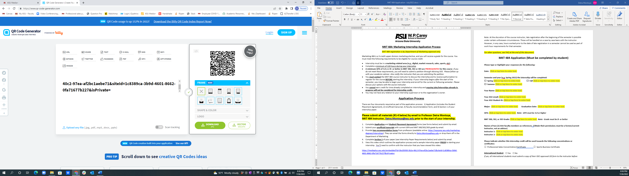
Note: At the discretion of the course instructor, late registration after the beginning of the semester is possible under certain unforeseen circumstances. These will be handled on a case by case basis with the instructor. However, in any case, hours worked prior to the date of late registration in a semester cannot be used as part of work hour requirements for that semester.

For other questions, see FAQ at the end of this document.

MKT 484 Application (Must be completed by student)

Please type or highlight your responses for the following:

Date: Click or tap here to enter text.

Semester and year (e.g, Spring 2022) the internship will be completed:

☐ Spring Click or tap here to enter text. ☐ Fall Click or tap here to enter text.

☐ Summer Click or tap here to enter text.

Your Name: Click or tap here to enter text.

Your ASU email: Click or tap here to enter text.

Your ASU Student ID: Click or tap here to enter text.

Major: Click or tap here to enter text. Graduation Date: Click or tap here to enter text.

GPA: Click or tap here to enter text. Note: GPA must be 3.0 or higher

MKT 300, 302, or 303 Grade: Click or tap here to enter text. Note: Grade must be B- or better

Names of two (2) ASU faculty members as references: (Obtain their permission; must be a former/current instructor, not an advisor)

Instructor 1: Click or tap here to enter text.

Instructor 2: Click or tap here to enter text.

Please indicate whether this internship credit will be used towards the following concentrations or certificates:

☐ Professional Sales Concentration/Certificate ☐ Sports Business Certificate

International Student ☐ Yes ☐ No

If yes, all international students must submit a copy of their ISSC approved I20 form to the instructor before beginning their internship. Failure to do so will result in being dropped from the class.

Student Placement Agreement

Internship Information- MUST BE COMPLETED BY STUDENT

The information you provide below will be used for a Student Placement Agreement (SPA). The SPA will be sent electronically via Adobe to your employer and the Dean for signatures. Please be sure to let your employer know this form will be sent to them in case it arrives in a spam folder. All information below must be completed before your application will be accepted.

Name of Sponsoring Company: Click or tap here to enter text.
Sponsoring Company Address:
Street Address: Click or tap here to enter text.
City: Click or tap here to enter text.
State: Click or tap here to enter text.
Zip Code: Click or tap here to enter text.

Is the internship remote/virtual? ☐ Yes ☐ No ☐ Both virtual and in-person

Supervisor/Contact Name: Click or tap here to enter text. (Name of the direct supervisor of the student internship, or individual who can sign the Student Placement Agreement to confirm the agreement between the company and ASU)
Supervisor/Contact Title: Click or tap here to enter text.
Supervisor/Contact Email: Click or tap here to enter text.
Supervisor/Contact Telephone Number: Click or tap here to enter text.
Sponsoring Company URL: Click or tap here to enter text.

Type of Agreement (check one box, typically either SPA or Paid SPA):

☐ SPA: Student Placement Agreement – Legal agreement between ASU and Sponsor Company for an unpaid internship.

☐ Paid SPA: Student Placement Agreement – Legal agreement between ASU and Sponsor Company for a paid internship.

☐ Sponsor’s Agreement – Signifies intent to make a Student Placement Agreement between ASU and the Sponsor Company related the length of the Student Placement Agreement between ASU and the Sponsor Company. Not common.

☐ Addendum: Indicates that a change in the contract terms have been requested by the Sponsor Company and ASU has agreed to these request(s). Not common.

Internship Term: Start date: Click or tap here to enter text. End Date: Click or tap here to enter text.
We will enter start/end dates for the Agreement. There is an option to choose a longer time period (up to 5 years). The option of choosing a 5 year period allows for the Sponsoring Company to obtain interns in the future without having to go through the ASU/Sponsoring Company agreement process we are currently engaged with these forms. It also covers any internships for the entire University. This makes it faster and easier to bring interns on board for the next 5 years no matter what their major might be.

Please check here if your Sponsoring Company would like to extend the agreement, and indicate an end date (up to five years) ☐ (check box) End Date: Click or tap here to enter text. Note, this is optional.

Educational Opportunity. Please provide a brief description of the educational opportunity (i.e. what you will be doing during the internship). You may copy/paste the job description provided by your employer here.

Click or tap here to enter text.

******************************************************************************************************************
MKT 484 Internship Paper Requirements - IMPORTANT

Please refer to the course Canvas site for a sample paper. Your paper should be submitted on Canvas.

Include a cover sheet, table of contents, and page numbers. The paper should be single-spaced.

Your paper consists of five sections. Please review the information below to insure that you include all required information in your paper.

1. Section I: Your Goals (due when you submit your application)
Describe your internship, and your expected goals, both company-oriented and personal. For example, what has your supervisor shared with you regarding his/her expectations of you? What do you hope to get out of this experience? This section should be about 1 page single-spaced (minimum), and completed and emailed to Professor Montoya (Detra.Montoya@asu.edu) prior to starting your internship as part of the MKT 484 application. It should also be included with your final paper.

2. Section II: The Journal
You should document what you are doing on a daily/weekly basis to accomplish your stated goals. You will need to maintain a daily or weekly journal and submit it with your paper. Please note that if you are submitting a weekly journal, you should include at least 1-2 paragraphs per week. Bullet points for a journal are not acceptable. Length for this section will vary, but should be representative of the hours worked (in other words, two sentences per week is not sufficient).

In addition, keep track of your hours on a weekly basis—please include a table with all of your weekly hours logged. You must provide documentation that you worked a minimum of 120 hours, signed by your employer. You can ask your employer to sign off on the table with your hours.

Your journal should be single-spaced.

3. Section III: Reflection and Assessment
In this section, you should discuss your overall assessment of the internship. Please be sure to answer all of the questions below.

a) What did you accomplish during your internship? Compare this with what you discussed in Section I and determine if there is any difference. Why is there a difference? How could the internship been improved?

b) Discuss discipline-specific knowledge you learned during your internship. For example, if your internship was digital marketing (or social media, sales, market research, sports-related, etc), describe key digital marketing (or social media, sales, market research, sports-related, etc) concepts and tools you learned. What is the role of digital marketing (or social media, event planning, sales, etc) within the organization? How does your role and department help create customer value?

c) What did you use from your classes (identify 3 classes) that helped you during your internship?

d) Include a self-assessment of your performance. How do you feel you performed during your internship?

Section III should be a minimum of 3-5 pages single-spaced (minimum is 3 FULL pages). Fewer than 3
pages will result in a grade reduction.

4. Section IV: Internship Performance Evaluation
Include an evaluation from your supervisor. This can be your employer’s own evaluation form, or submitted as a letter—the letter should be written on company letterhead and signed by your supervisor. The letter should discuss your accomplishments and overall performance. This is an evaluation letter about your performance during the internship, not a generic recommendation letter.

5. Section V: Sample of Work
Include examples of the materials you create during your internship such as pictures of an event, screenshots of social media posts, press releases, presentations, etc. You can omit any confidential company information.

6. Important Grade Information:
This is a 3-credit hour class that can count as one of your electives as a Marketing major or it can be used as an upper division business class for other majors. Therefore, your final report should be equivalent in quality and professionalism to a paper submitted in an upper division course. Please refer to the grading rubric in Canvas. Please review all of the paper requirements carefully.

The due date is the last day of the regular semester (prior to finals week). Please try to submit your paper within 2 weeks of completing your internship. If you submit the paper after the semester/summer session due date, you will receive a “Z” (course in progress) which will be changed to a grade when your project is received and graded.

*Here is a video that reviews a sample internship paper:
https://mediaplus.asu.edu/embedded?id=26423c32-1eb1-463a-a31c-043a91c0f3c9&siteId=1c8389ca-3b9d-4601-8662-0fa71677b227&isPrivate=

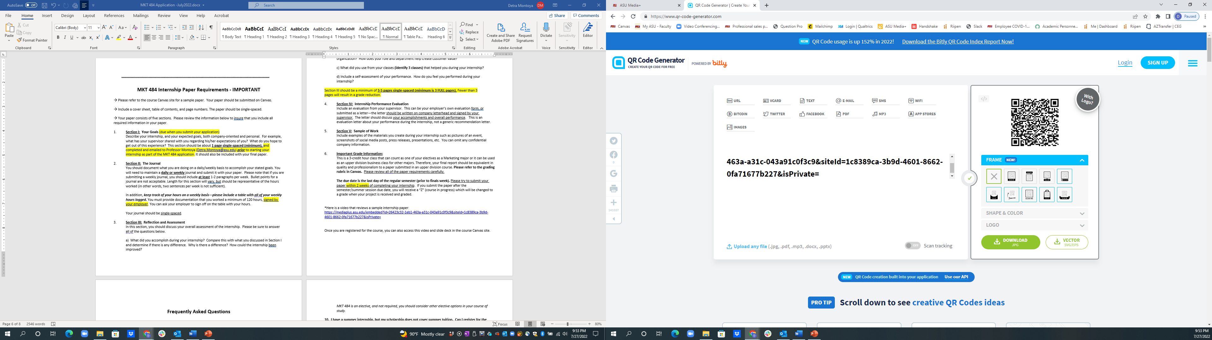 QR Code for the video

Once you are registered for the course, you can also access this video and slide deck in the course Canvas site.
Frequently Asked Questions

- My internship will end after the regular semester ends. Will that affect my grade?
If you submit the paper after the last day of the semester, you will receive a “Z” (course in progress) which will be changed to a letter grade when your project is received and graded.

- I’ve been working with my employer for the past several months or year. Can I receive credit for my internship?
Unfortunately, we do not offer credit for ongoing work, or for an internship that is already in progress. If your internship changes, we may be able to offer credit for a “new” internship with your employer if you can provide an updated job description to show the new/different projects. However, only hours worked under the new project will count towards the 120+ hours requirement.

- I am not a Marketing major, but my internship is marketing-related. Can I still register for MKT 484?
Yes, as long as you meet the requirements listed above and you are a W. P. Carey BS major (BA majors may also be eligible—follow up with instructor for more information)

4. I am a Marketing major, but my internship is non marketing-related (e.g, accounting-related). Can I still register
for MKT 484?
No, your internship should be marketing-related. Fortunately, WPC 484 and BIS 484 are other options for internship course credit.

5. Can I earn more than 3 credits for my internship or take the course twice?
MKT 484 is a 3-credit course and can only be taken once. Refer to WPC 484 or BIS 484 for other options. For double certificates/majors (e.g., Professional Sales AND Sports Business), please see Internship Coordinator for more information.

6. My internship starts in the middle of the semester. Can I still register for MKT 484?
Possibly. You may be able to begin your internship now, and register for the following semester. See the Internship Coordinator for more info.

7. Will my internship count towards my concentration or certificate (e.g., Professional Sales)?
Most likely! Please see the Internship Coordinator to confirm that your internship is in a related field (e.g., For a Professional Sales concentration, your internship should be sales-related, or for a Sports Business major, the internship must be sports-related).

8. I haven’t taken MKT 300/302/303. Can I still register?
MKT 300/302/303 is a prerequisite, and is required. You will need to wait until you have completed the course with a B- or better to register for MKT 484. You cannot take the course concurrently so you’re your course schedule accordingly.

9. I received a C in MKT 300/302/303 or my GPA is below 3.0. Can I still register?
If you received a C in the MKT course and/or your GPA is below a 3.0, you can submit a petition through Advising SOS, or you will need to consider other internship course options such as WPC 484 or BIS 484. If MKT 484 is an elective, and not required, you should consider other elective options in your course of study.
10. I have a summer internship, but my scholarship does not cover summer tuition. Can I register for the
course in the fall?
Yes, you may have the option to simply move the course registration (when the course appears on your transcript) to fall, but complete all of your work (e.g. journal, paper) during the summer. Your paper should be submitted by the end of summer/early fall. Please discuss this option with the instructor.

For questions, please contact the MKT 484 instructor, Professor Detra Montoya Detra.Montoya@asu.edu.

Rev. July 2022

